Supplementary Material
S1. Supplementary Methods & Materials
S1.1. MRI Quality Control for Motion
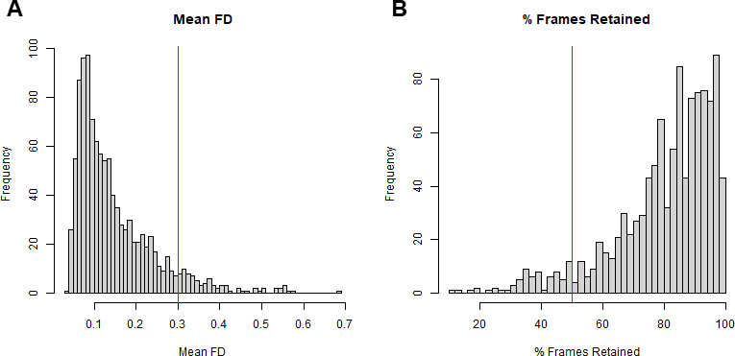Figure S1. Histograms of motion-related quality control metrics (mean framewise displacement [FD], A; % frames retained after motion censoring, B). Red lines indicate thresholds for excluding participants (mean FD > 0.3 mm, A; frames retained < 50%, B).
S1.2. ComBat Harmonization
Previous work has demonstrated that ComBat harmonization can mitigate scanner- and site-specific differences in network-level FC features, e.g., intra-network DMN (DMN x DMN) connectivity (Yu et al., 2018). We evaluated the impact of ComBat in our data by testing for scanner-related differences in DMN x DMN connectivity before and after applying ComBat. As shown in Figure S2A, unharmonized FC data from the various sites exhibited heterogeneous slopes and intercepts in linear regression models of DMN x DMN connectivity as a function of age. After residualizing for the age effect, a one-way analysis of variance (ANOVA) revealed significant scanner- and site-specific differences in DMN x DMN connectivity, F(15) = 2.2, p = .005 (Figure S2C). After applying ComBat harmonization, intercepts of the scanner-specific age regression models were slightly more aligned with the sample-wide average age effect (Figure S2B). Further, DMN x DMN connectivity was only marginally different across sites and scanners after residualizing for age differences, F(15) = 1.5, p = .09 (Figure S2D). These reductions of site and scanner differences are comparable to those previously reported (Yu et al., 2018).
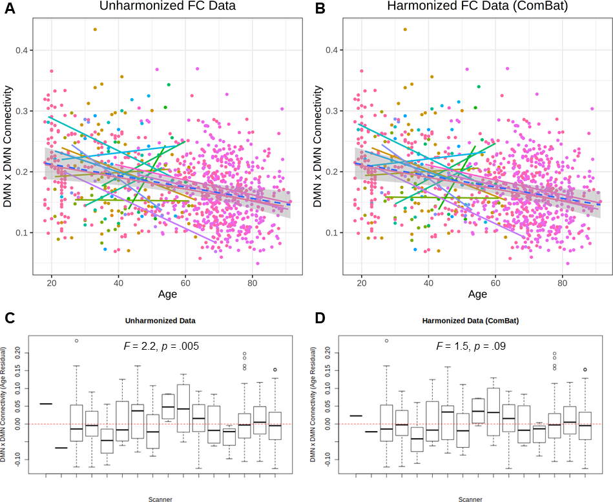
Figure S2. Comparison of intranetwork default mode connectivity (DMN x DMN) before (A & C) and after ComBat harmonization (B & D). Scatterplots (A & B) depict average DMN x DMN connectivity (y axis) as a function of age (x axis) across all sites and scanners (different colors). Solid lines represent scanner-specific regression slopes. Dotted lines and shaded regions represent full sample-wide regression slopes and 99% confidence band. Boxplots (C & D) depict average DMN x DMN connectivity residualized for age (y axis) across all sites and scanners (x axis). Scanner-related differences in connectivity are tested with a one-way analysis of variance (ANOVA). Site and scanner labels are omitted in order to maintain anonymity of DIAN participants.
S1.3. Gaussian Process Regression
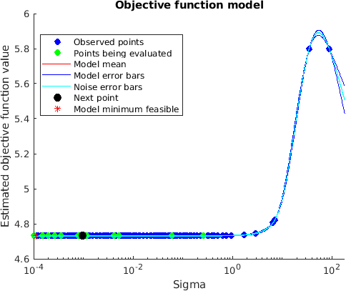
Figure S3. Tuning curve of σ hyperparameter in GPR model training.
S2. Supplementary Results
S2.1. Results without ComBat Harmonization
We also performed the major analyses outlined in the results section in data that was not harmonized for scanner and/or site differences. As shown in Figure S4, the model performed comparably well when trained on unharmonized FC data (Training sets: R² = .681, MAE = 8.576, RMSE = 10.450; Test sets: R² = .725, MAE = 8.242, RMSE = 10.383).
Further, the hypothesis-directed group differences in FC-BAG were also observed in the unharmonized dataset, including the effects of CDR status (β = 2.88, p < 0.001, η_{p}² = 0.04), tau positivity (β = -2.11, p = .036, η_{p}² = 0.02), and APOE genotype (β = -1.85, p = .017, η_{p}² = 0.02) (see Table S1 and Figure S5).
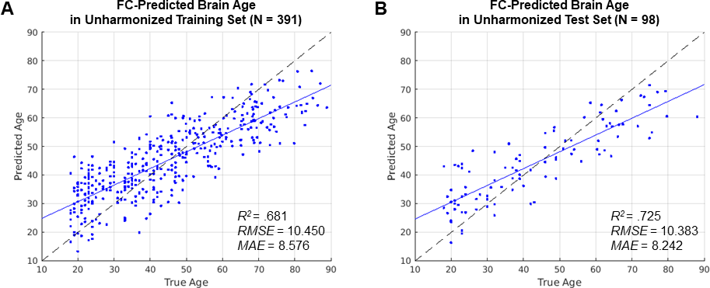
Figure S4. Performance of the FC-predicted brain age model using unharmonized data. Scatterplots show the cross-validated model predictions in the training set (A) and in the held-out test set (B). Age predicted by the model (y axis) is plotted against true age (x axis). Blue lines represent regression lines. Dashed black lines represent perfect prediction. Model performance is evaluated by proportion of variance explained (R²), root-mean-square error (RMSE), and mean absolute error (MAE).
 | MODELS
 | A. Symptomatic AD | B. Preclinical Amyloid | C. Preclinical Amyloid & Tau | D. Preclinical APOE | E. Full Model
Test Sample | All analysis sets | Cognitively normal only | Cognitively normal only | Cognitively normal only | All analysis sets
Predictors
Intercept | 32.62 (3.49)*** | 28.07 (4.35)*** | 33.33 (4.55)*** | 31.11 (4.24)*** | 33.60 (4.24)***
CDR > 0 | 2.88 (0.68)*** |  |  |  | 3.70 (1.16)**
Amyloid + |  | -1.89 (0.80)* | 0.02 (0.98) |  | 0.14 (0.98)
Tau + |  |  | -2.11 (1.00)* |  | -1.37 (0.92)
APOE ε4 + |  |  |  | -1.85 (0.77)* | -1.42 (0.79)^
Age (y) | -0.63 (0.04)*** | -0.56 (0.05)*** | -0.66 (0.05)*** | -0.60 (0.05)*** | -0.66 (0.05)***
Sex = female | -1.52 (0.63)* | -1.03 (0.78) | -1.18 (0.82) | -1.08 (0.78) | -1.37 (0.75)^
Education (y) | -0.06 (0.11) | -0.0002 (0.14) | -0.001 (0.15) | -0.03 (0.14) | 0.007 (0.14)
Race = white | 2.49 (0.93)** | 2.16 (1.16)^ | 2.94 (1.51)^ | 2.09 (1.16)^ | 2.77 (1.46)^
Table S1. Linear regression models predicting FC-BAG using unharmonized data. Model estimates are presented as beta weight (standard error). CDR = Clinical Dementia Rating. *** p < .001, ** p < .01, * p < .05, ^ p < .10.
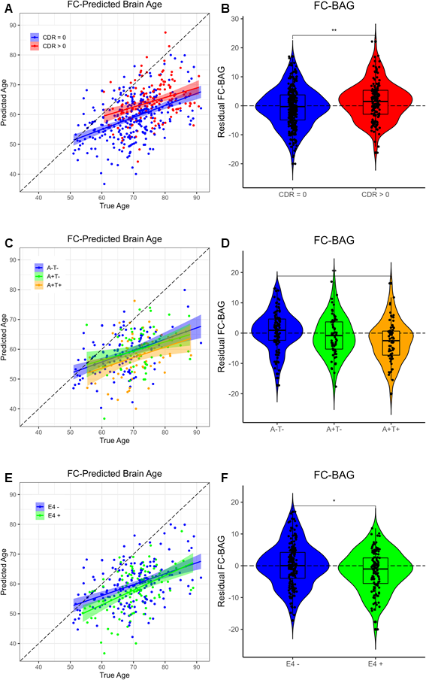
Figure S5. Group differences in FC-predicted brain age in the analysis sets using unharmonized data. Comparisons are presented between cognitively normal (CDR = 0, blue) vs. symptomatic AD (CDR > 0, red) (A, B); A-T- (blue) vs. A+T- (green) vs. A+T+ (gold) (C, D); and cognitively normal APOE ε4 carriers (blue) vs. non-carriers (green) (E, F). Scatterplots (A, C, E) show predicted vs. true age for each group. Colored lines and shaded areas represent group-specific regression lines and 95% confidence regions. Dashed black lines represent perfect prediction. Violin plots (B, D, F) show residual FC-BAG (controlling for true age) in each group. Group differences are reported from pairwise independent-samples t tests. *** p < .001, ** p < .01, * p < .05, ^ p < .10.
S2.2. Effects of Symptomatic AD Severity
Residual FC-BAG was normally distributed in all groups defined by cognitive status (Shapiro-Wilk statistics > 0.96, ps > 0.28). Variance in residual FC-BAG did not differ between groups (Levene’s statistic = 0.17, p = 0.84).
Pairwise independent-samples t tests revealed that residual FC-BAG was only marginally elevated in CDR > 0.5 participants relative to CDR = 0 (t = 1.64, p = .109, see Supplementary Figure 6), but did not differ significantly between CDR = 0.5 and CDR > 0.5 (t = 0.07, p = .945).
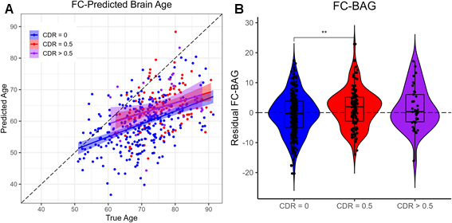
Figure S6. Group differences in FC-predicted brain age in the analysis sets. Comparisons are presented between cognitively normal (CDR = 0, blue), very mild dementia (CDR = 0.5, red), and mild-to-moderate dementia (CDR > 0.5, purple) groups. The scatterplot (A) shows predicted vs. true age for each group. Colored lines and shaded areas represent group-specific regression lines and 95% confidence regions. Dashed black lines represent perfect prediction. The violin plot (B) shows residual FC-BAG (controlling for true age) in each group. Group differences are reported from pairwise independent-samples t tests. *** p < .001, ** p < .01, * p < .05, ^ p < .10.

